Serial Cannot Be Managed From The Online Store.

序列号无法从在线商店中管理

**Symptoms**

* I have an Educational license
* 我拥有一个教育版许可
* I am trying to add my license to my account on the Unity Online Store
* 我正视图从Unity在线商店中将我的许可证添加到我的账户
* I receive this error:
* 我收到这个错误

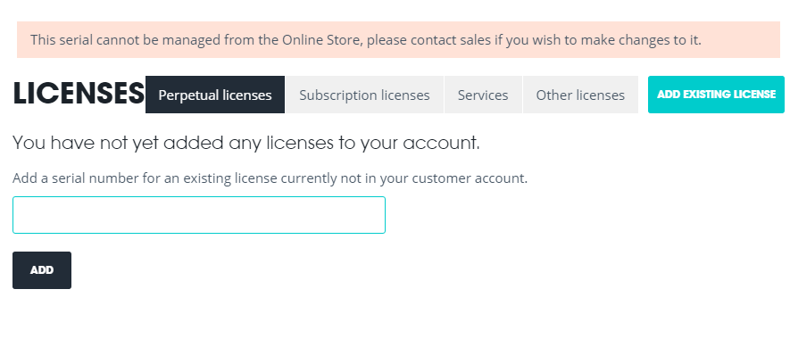

**Cause**

Educational licenses have added security features. This means that they cannot be managed through the Online Store and need to be managed through us.

教育版许可证增加了安全功能。这以为着它们不能通过在线商店进行管理，需要通过我们来管理。

**Resolution**

To make changes to your license, for example adding activations or upgrading you will need to contact sales [here.](http://unity3d.com/sales/finder)

要更改您的许可证，例如添加激活或者升级，您需要再此处与销售人员进行联系。

To return activations on your license, you can get in touch with Support [here](https://support.unity3d.com/hc/en-us/requests/new).